Commodore PET/CBM 6502 Ribbon Cable Adapter Rev. 0

**Module Description**

# Introduction

The 6502 Ribbon Cable Adapter is part of the PET Diagnostic Clip assembly. It replaces the actual DIP40 clip, which is available from Mouser etc. for about US$50. It provides a connection of the 6502 µprocessor to a 40 pin box header. The 6502 is inserted into its socket and it is then connected to the socket of the 6502 on the mainboard of the PET.

The Ribbon Cable Adapter (with or without the clip) can remain in the mainboard for normal operation.

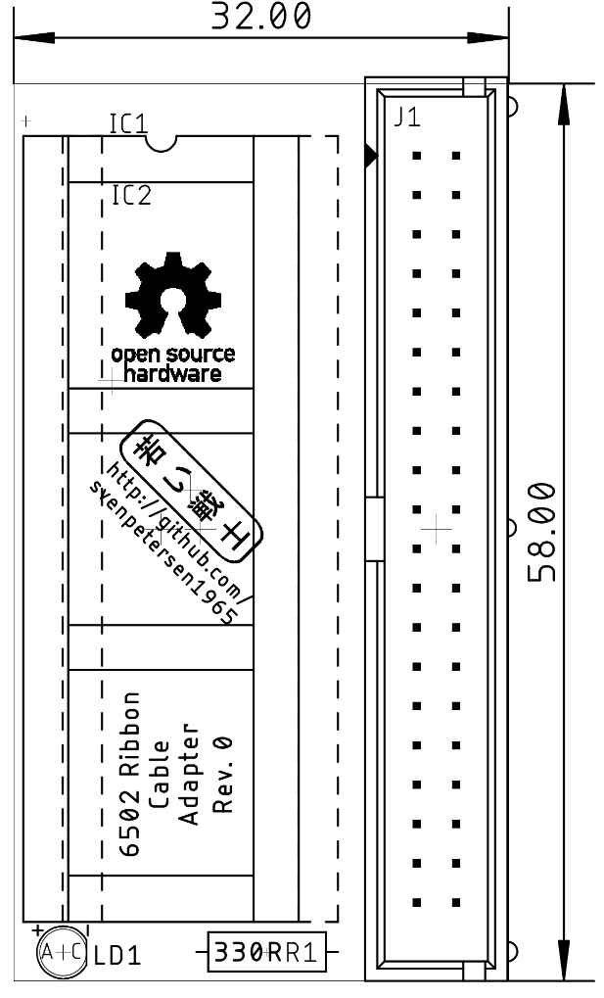

Figure : Dimensions of the 6502 Ribbon Cable Adapter#

# Connectors

## J1 – Clip Connector

| Signal | Pin | Pin | Signal |
| --- | --- | --- | --- |
| GND (6502, Pin 1) | 1 | 2 | /RES |
| RDY | 3 | 4 | PHI2 |
| PHI | 5 | 6 | S.O. |
| /IRQ | 7 | 8 | PHI0 |
| /NOROM | 9 | 10 | n.c. (6502, Pin 36) |
| /NMI | 11 | 12 | n.c. (6502, Pin 35) |
| SYNC | 13 | 14 | R//W |
| 5V | 15 | 16 | DB0 |
| AB0 | 17 | 18 | DB1 |
| AB1 | 19 | 20 | DB2 |
| AB2 | 21 | 22 | DB3 |
| AB3 | 23 | 24 | DB4 |
| AB4 | 25 | 26 | DB5 |
| AB5 | 27 | 28 | DB6 |
| AB6 | 29 | 30 | DB7 |
| AB7 | 31 | 32 | AB15 |
| AB8 | 33 | 34 | AB14 |
| AB9 | 35 | 36 | AB13 |
| AB10 | 37 | 38 | AB12 |
| AB11 | 39 | 40 | GND (6502, Pin 21) |

It is advised to use a ribbon cable, not longer than 15cm and to install the strain reliefs.

## IC1(socket for the 6502, IC2 (6502 pin header)

| Signal | Pin | Pin | Signal |
| --- | --- | --- | --- |
| To J1 Pin 1(GND) | 1 | 40 | /RES |
| RDY | 2 | 39 | PHI2 |
| PHI | 3 | 38 | S.O. |
| /IRQ | 4 | 37 | PHI0 |
| /NOROM | 5 | 36 | To J1, pin 10 |
| /NMI | 6 | 35 | To J1, pin 12 |
| SYNC | 7 | 34 | R//W |
| 5V | 8 | 33 | DB0 |
| AB0 | 9 | 32 | DB1 |
| AB1 | 10 | 31 | DB2 |
| AB2 | 11 | 30 | DB3 |
| AB3 | 12 | 29 | DB4 |
| AB4 | 13 | 28 | DB5 |
| AB5 | 14 | 27 | DB6 |
| AB6 | 15 | 26 | DB7 |
| AB7 | 16 | 25 | AB15 |
| AB8 | 17 | 24 | AB14 |
| AB9 | 18 | 23 | AB13 |
| AB10 | 19 | 22 | AB12 |
| AB11 | 20 | 21 | GND |

The precision round pins are very fragile. It is advised to keep them in a second DIP40 round pin socket.

# Revision History

## Rev. 0

* Working prototype